**Rainbow Lakes West 3rd Addition**

**HOA Annual Meeting**

Meeting Minutes

September 17, 2016

**Opening**

The annual meeting of the Rainbow Lakes West 3rd Addition Home Owner’s Association, was called to order at 1:00PM on September 17, 2016 by Patrick Trant, President.

**Board Members Present**

Patrick Trant (President), Steve Cooper (Vice President), Jolene Kaufman (Secretary), Mary Hill (Zone Representative 2), and Mike Wise (Zone Representative 4).

**Homeowners Present**

Jason Jones

Judith Just

Vernon Just

Doug Kaufman

Dan Kennedy

Earl Lauer

David Pote

Richard Rose

Brad Sweet

Ron Wadsack

Rebecca Wise

Amy Wood

**A) Presiding Officer**

* Patrick Trant, President presided over the meeting.

1. **Assignment of time keeper and two tellers to approve the minutes from the annual meeting.**

* Steve Cooper assigned as timekeeper.
* Earl Lauer and Brad Sweet assigned as tellers to approve meeting minutes.

1. **Introduction of Current Board Members**

* Patrick Trant (President), Steve Cooper (Vice President), Jolene Kaufman (Secretary) and Zone Representatives: Mary Hill (2), and Mike Wise (4).

1. **Introduction of New Home Owner Association Members**

* No new Home Owner Association Members present.

1. **Treasurer’s Report**

* Steve Cooper, Vice President presented the treasurer’s reports for Phil Iwinski, Treasurer of the HOA, who was unable to attend the meeting.
* Steve presented the most current treasurer’s report dated July 15, 2016 (attached).
* Steve explained the reason for the increase in the electric bill(s) is the result of the lake aerators running more often. He also explained major expenses reflected on the report:

Lake Engineers Report, Tree Removal from storm damage, and the rebuilding of the Common Area Dock (all reported in previous monthly meeting minutes).

HOA member, Richard Rose, pointed out that there appeared to be an error on the report: that $3,000 was paid to Eager Beaver for beaver control on Reservoir B – but, it was resolved that the expense was entered on the wrong line of the report and that the $3,000 was actually paid for the rebuilding of the dock on the Common Area. The error will be corrected.

* Steve presented the proposed budget for the 2016-2017 year, as well as the 5-year estimated budget (both attached).
* Brad Sweet moved to approve the proposed 2016-2017 HOA budget, as presented.

Mike Wise seconded the motion.

**Motion carried 17-0**

* Steve presented the 5-year estimated budget and explained that it may be necessary in the future to increase membership dues to cover expenses and maintain reserve funds.

1. **Old Business**

* There was no old business from the 2015 annual meeting discussed.

1. **New Business**

* Patrick Trant opened the floor for nominations to fill the two open positions on the Executive Board.
* Mary Hill motioned to nominate Mike Wise to an open board position.

Steve Cooper seconded the motion.

**Motioned carried 17-0.**

* Steve Cooper motioned to nominate Mary Hill to an open board position.

Jason Jones seconded the motion.

**Motion carried 17-0.**

* Patrick Trant opened the floor for nominations to fill the two open positions on the Architectural Control Committee.
* Steve Cooper motioned to nominate David Pote to an open ACC position.

Mike Wise seconded the motion.

**Motion carried 17-0.**

* Mary Hill motioned to nominate Jason Jones to an open ACC position.

Steve Cooper seconded the motion.

**Motion carried 17-0.**

1. **Open Items from the Floor**

* Richard Rose suggested that items submitted to the Architectural Control Committee for approval, be recorded for informational purposes for all HOA members.
* Patrick Trant agreed that the information as well as past information could possibly be recorded electronically for informational purposes.
* Mary Hill inquired on the status of the new covenants being drafted for the HOA.
* Patrick Trant explained that a draft of the new covenants has been provided by the HOA attorney and, that the board is in the process of revising the draft. He stated when the final version is complete, it will be presented to HOA members to review. He noted that a duly called meeting will need to be scheduled for HOA members to vote for or against the proposed new covenants.
* Richard Rose inquired about the neighborhood improvement survey that was sent out to members in recent months.
* Patrick Trant explained that a very small percentage of HOA members responded to the survey, but agreed to post the results on the HOA web-site.
* Steve Cooper proposed that it may be time for HOA members to look at hiring an HOA management company to ensure the increased value of our homes. Attached is a letter from Steve outlining his concerns.

However, as noted in his letter, the attached proposal from one of the HOA management companies he contacted is not included in this document. If an HOA member is interested in reviewing the proposal, please email the board and a copy will be provided.

* Most of the HOA members present at the meeting acknowledged Steve’s concern and were in agreement of researching and considering the possibility of hiring an HOA management company.
* Patrick Trant explained that finalization and approval of the new Covenants and By-Laws by the HOA members is necessary first before proposing hiring an HOA management company, all of which must be approved by the defined majority of HOA members.
* Mary Hill posed the question that if an HOA management company was hired, which board positions, if any, would be effected and how?
* Richard Rose also questioned the credentials of the different positions of an HOA management company.
* Patrick Trant explained that much research will need to take place when considering and hiring an HOA management company. He also explained that a meeting would need to be held where the management company could present services offered and HOA members would have the opportunity to address their questions and concerns.

1. **Adjournment**

* At 2:00 PM Mary Hill motioned to adjourn the annual meeting.

Vernon Just seconded the motion.

Patrick Trant declared the meeting be adjourned.

______________________________

Respectfully submitted by

Jolene Kaufman, Secretary

Approved by: Earl Lauer and Brad Sweet

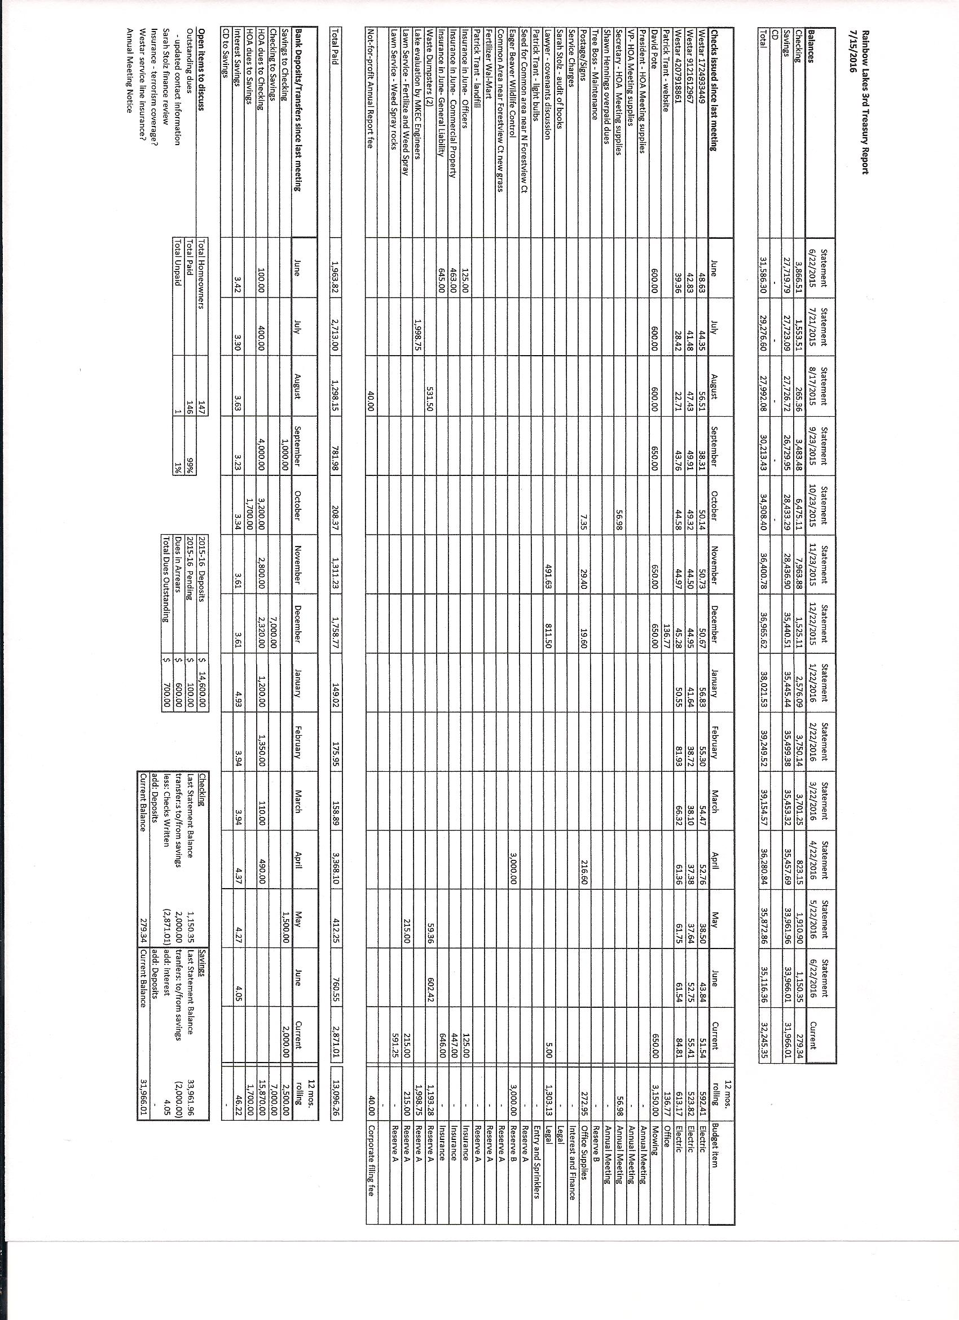





Private Homeowner Rainbow Lakes West Third HOA

Wichita, KS 67235 September 18, 2016 1

September 16, 2016

Dear fellow homeowners,

I believe our neighborhood is maturing and our current HOA board covenants and bylaws were developed and reflect views from when our neighborhood was newer. I believe we need to mature along with the neighborhood in order to ensure the increased value of our homes. One way to develop this maturity is to hire a professional HOA Management company to oversee and assist the efforts of our completely volunteer board of directors.

Because we have two year terms for our board members we often have turnover in those positions. This ensures fresh ideas and promotes community involvement. At times it is difficult to fill the positions on the various boards such as the Executive board with 4 members, The Zone Reps with 7 members and the Architectural Committee. Sometimes we do not have enough members to fill all of the open positions. That leaves gaps in our ability to cover all of the required jobs that need to be done. We are requesting that the homeowner membership of the HOA get involved and serve on the board as a community service to your neighborhood.

In addition to volunteers, a professional HOA Management company fills those gaps. They reduce the dependency of our membership from being completely reliant on volunteers to handle and coordinate very important things like finance, collection of dues, paying for maintenance of several acres of common areas and lakes, updating and enforcing covenants, settling disputes, legal issues, developing community activities and beautifying our neighborhood, just to name a few.

My observation from being on our HOA Executive Board for 4 years is that the job is mostly thankless in the eyes of the majority of members, although I have heard many gestures of appreciation from homeowners. Private boards in general also have a way of focusing on local distractions rather than the big picture at times. It is human nature to gravitate to areas you are more familiar with. I believe we need a non-biased third party to make sure we protect our HOA for the future and ensure the highest value for our homes.

I have attached a proposal from one HOA Management company. I have spoken to a few of them. The company proposal I attached has good credentials, very responsive, a comprehensive offering of services and I believe a reasonable price. The price adds up to about $50 per year per home. I believe they would bring much more equity value to each home than the $50 per year cost.

Steve Cooper,

Vice President Rainbow Lakes West Third HOA